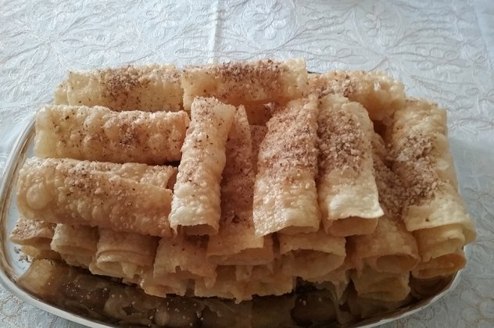
Δίπλες(Deep-fried pastry)

Ingredients Execution
For the dough
• 10 eggs
• 7 cups flour
• ½ wine glass of ouzo
• Olive oil for frying
For the syrup
• 1 kg. (5 cups) honey,
Pure Greek Honey with fresh honeycomb
• 1 kg. (5 cups) sugar
• 2 cups water In a bowl mix the eggs with the ouzo.
Add flour and knead until the dough becomes soft. Roll out the pastry about ½ cm. thick and cut into slices. In a deep frying pan heat the olive oil, drop in the slices and fold. Turn them quickly and fry. Remove immediately and place in a bowl. Boil the sugar with the water. Add honey and boil until it thickens. Drizzle the syrup over the diples.
Serve on a platter, sprinkled with crushed walnuts

