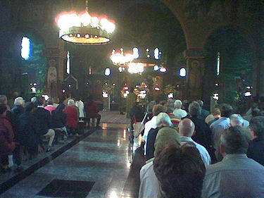

[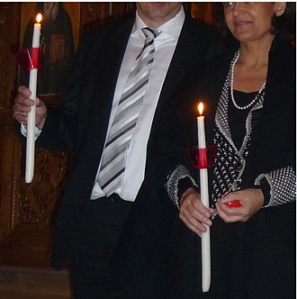](https://el.wikipedia.org/wiki/%CE%9B%CE%B1%CE%BC%CF%80%CE%AC%CE%B4%CE%B1)

[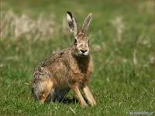](https://el.wikipedia.org/wiki/%CE%9B%CE%B1%CE%B3%CF%8C%CF%82)

[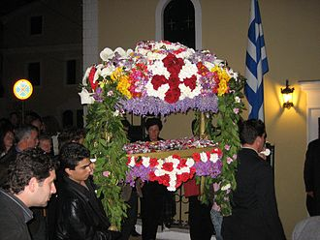](https://el.wiktionary.org/wiki/%CE%95%CF%80%CE%B9%CF%84%CE%AC%CF%86%CE%B9%CE%BF%CF%82)

[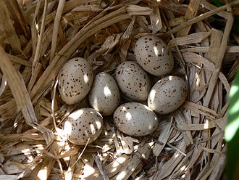](https://el.wikipedia.org/wiki/%CE%91%CE%B2%CE%B3%CF%8C)

[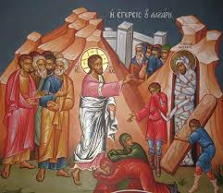](https://el.wikipedia.org/wiki/%CE%9B%CE%AC%CE%B6%CE%B1%CF%81%CE%BF%CF%82_(%CF%8C%CE%BD%CE%BF%CE%BC%CE%B1))

[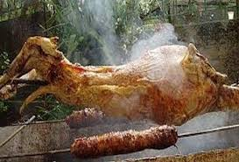](https://el.wiktionary.org/wiki/%CE%B1%CF%81%CE%BD%CE%AF)

[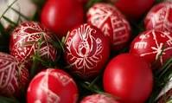](https://el.wikipedia.org/wiki/%CE%A0%CE%AC%CF%83%CF%87%CE%B1)

[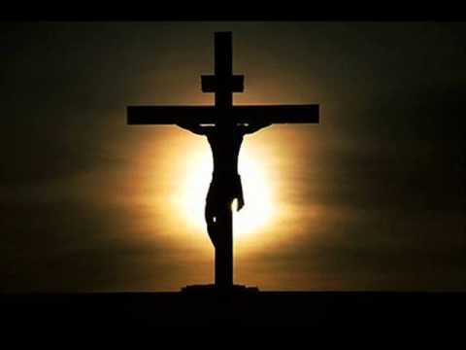](https://el.wikipedia.org/wiki/%CE%A3%CF%84%CE%B1%CF%8D%CF%81%CF%89%CF%83%CE%B7)

[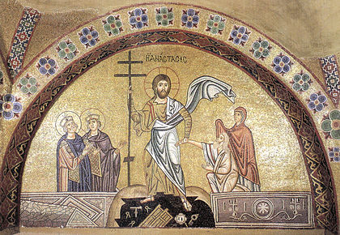](https://el.wikipedia.org/wiki/%CE%91%CE%BD%CE%AC%CF%83%CF%84%CE%B1%CF%83%CE%B7_%CF%84%CE%BF%CF%85_%CE%A7%CF%81%CE%B9%CF%83%CF%84%CE%BF%CF%8D)